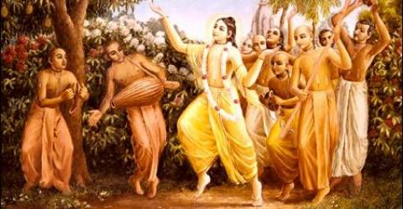

November 2010 Edition
www.soldiersofgodhead.yolasite.com
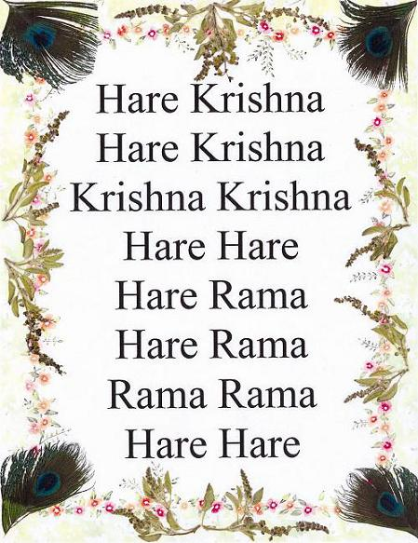

Contents

Sr.no Topic Page no
- The Four Regulative Principles 4

- The Month of Kartik 12

- Damodarashtakam 18

- Yuga Dharma 24

- The significance of Vegetarianism 27

- The Four Regulative Principles
For the purpose of smooth progress in any field in life certain rules, regulations and principles are essential. Just like in a school, there are certain rules and regulations which are binding on all the students and there are certain rules and regulations for the teachers. These rules and regulations ensure that there is discipline among the students and the teachers are working efficiently. In this way, smooth running of the institution is ensured. Similarly, for smooth progress in spiritual life, it is essential to follow certain rules and regulations. These rules and regulations are laid down in shastras and are established by the authorities either, the bonafied spiritual masters and representatives of the Supreme Personality of Godhead Lord Sri Krishna. Just as in the case of the school, the rules and regulations are established by the authorities, i.e by the principal or head master similarly, in case of spiritual life, the rules and regulations cannot be established by anyone except the authorities as mentioned above. One cannot manufacture his/her own rules and regulations or modify the laid down rules and regulations as per one’s own convenience. Such self made rules and regulations or the modified versions are not authorized and are thus ineffective and prohibited.
For a better understanding of what should be done and what must not be done, how it must be done, by whom and where it must be done, one must take shelter of the shastras and authorized scriptures like the Srimad Bhagavad Gita, the Srimad Bhagavatam and so on. His Divine Grace A.C. Bhaktivedanta Swami Prabhupada who belongs to the disciplic succession extending back to Lord Krishna Himself, established the four regulative principles for all those who wish to progress in spiritual life. Following is a brief description of each of the four regulative principles:-
- No meat eating:-
One who aspires to progress on the path of Krishna Consciousness must not consume any form of meat. Red meat, flesh of any animal i.e dead or alive, fish, eggs etc must all be avoided. One must consume pure vegetarian food like food grains, vegetables, fruits, milk products etc. There are people who promote non-vegetarianism for the purpose of their business by saying that one can get energy and strength only by eating non-vegetarian food. But this is a false notion. Vegetarian diet is rich in natural fat, proteins and essential vitamins and minerals. And by eating pure vegetarian food and that too prasadam, one does not incur sins of killing and eating an innocent creature. One must consume only prasadam or the food which is first offered to Krishna. And what kind of food can be offered to Krishna? Patram Pushpam Phalam Toyam Yo Me Bhaktya Pracchte or “if one offers to me with love and devotion a leaf, a flower, a fruit or even a little water, I will accept it.” Bhagavad Gita 9.26. Here Lord Sri Krishna has personally said that he wants pure vegetarian foodstuff to be offered to Him as bhog. He is not asking for chicken tandori or meat or fish or eggs. He is asking for fruits and other pure things.
It is also important to note, that He accepts bhog only when it is offered with love and devotion. The word ‘Bhaktya’ signifies this. The leaf mentioned in the above text means the tulsi leaf. The Lord does not accept any bhog if it is offered without a tulsi leaf or without love and devotion. One must eat only the food which is first offered to the Lord or is worth offering to the Lord. Abominable things like meat must be avoided.

- No intoxication:-
One who is under the influence of some form of intoxication and is not in a proper state of mind, cannot understand the injunctions of the shastras and make smooth progress in Krishna Consciousness or spiritual life. Such a person indulges in all forms of abominable activities and acts in defiance of the shastras. Hence anyone who wants to progress in Krishna Consciousness must stop drinking alcohol, smoking cigarettes, taking any form of drugs and other intoxicants. Only when one achieves a proper state of mind and understands things as they are can he begin to progress in Krishna Consciousness. In India, there is a class of yogis known as Nang Sadhus. They are the followers of Lord Shiva and imitating Lord Shiva they drink alcohol, take drugs and other intoxicants and say that because Lord Shiva does it, we will also do it. But they never consider drinking poison like Lord Shiva did. Such a show case of devotion is not true devotion. It is only an excuse to enjoy sense gratification. One must stop all forms of intoxication and achieve a proper and clean state of mind. Only then can one begin acting in Krishna Consciousness.

- No illicit sex:-
The purpose of sex life is to beget Krishna Conscious children and not simply sense gratification. The aspiring candidate must not indulge in illicit sex life like a cat or dog. Animals do not have intelligence. Therefore they engage in illicit sex life. If a human being is acting in the same way then what is the difference between an animal and a human being? Animal life means simply eating, sleeping, mating and defending. If a human being lives in the same manner, then he is in a lower condition of life. Illicit sex means sex before marriage, sex outside of marriage and more than required sex within marriage. Even to look at the opposite sex with wrong intentions is a subtle form of illicit sex and hence must be avoided. All forms of illicit sex must be avoided for progress in Krishna Consciousness.

- No Gambling:-
Gambling means any form of investment with expectation of higher returns from an uncertain source which to be used for the personal sense gratification of the gambler or his family, friends, relatives, organization etc. Gambling gives rise to greed in a human being and makes him engage in other abominable activities owing to windfall gains or losses. Having acquired lots of money in a short time, one wants to immediately spend it on instant sense gratification and when he losses lots of money in a short time, he wants more money to invest further in gambling with the expectation of recovering from the losses. Gambling ruins one’s life and is a major road block for progressing in Krishna Consciousness. Anyone who is aspiring to progress in devotional service must avoid gambling at all costs. Even investments in the stock market is gambling because the returns from the investment are uncertain and lead to misconduct on part of the investors who are puffed up with greed and anxiety. Hence, a sincere candidate must understand the consequences of gambling and considering it as a stumbling block in devotional service to the Lord, must avoid it in all circumstances.
One who is sincerely aspiring to make progress in Krishna Consciousness must at all costs adopt and follow these four regulative principles as established by Srila Prabhupada, the Founder Acharya of the International Society for Krishna Consciousness. No deviations are allowed in case of these regulative principles. One must not change them to suit his/her life style. They must be followed strictly to gain the best results. By following them sincerely for a while, one can notice various positive changes in one’s life. One becomes physiologically and psychologically pure. His senses being engaged in the service of Lord Krishna become purified. One gains a positive outlook towards life, develops love and compassion for all living entities and above all makes rapid progress in Krishna Consciousness or spiritual life. Suddenly adopting these principles in life can be difficult. One can adopt them one at a time and follow each of them without any deviations. How one adopts them is not important but what is important is that one must follow them without any deviations or modifications.

By following these regulative principles one becomes an ideal human being and capable of making spiritual inquiries. Being in a lower condition of life, one cannot make such inquiries since one is more concerned about sense gratification rather than discharging devotional service to Lord Sri Krishna, the Supreme Personality of Godhead. The purpose of these principles is not to simply disengage the senses from materialism and frustrate them but to disengage them from materialism and to engage them in satisfying the senses of Lord Sri Krishna. Following the regulative principles sincerely, one becomes a fit candidate to go back home, back to Godhead.

Hare Krishna!

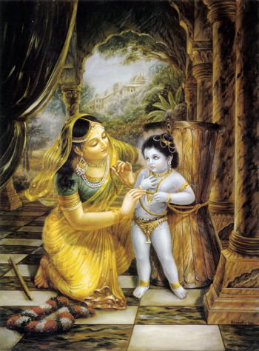
The holy month of Kartik coincides with the vaishnava month of Damodara the period between November and December.

- The Month of Kartik
Chaturmasya is the four-month period, consisting of the rainy and autumn seasons in India, during which Vaishnavas perform austerities to invoke the mercy of the Lord. Traditionally, itinerant priests and preachers would take a break from their travels during this time. Nowadays, observers refrain from eating certain foods. The last month of Chaturmasya is known as Karttika, and is the holiest month of the year for Vaishnavas.
Two major festivals during Karttika are Diwali and Govardhan Puja. Itinerant priest and preacher Sacinandana Swami has this to say about Karttika: "During the month of Karttika, which falls across October and November in the lunar calendar, devotees of Lord Krishna are advised to increase their concentration on His worship by dedicating their daily devotional hearing and chanting to Srimati Radharani, His eternal consort. . . anyone can apply this principle anywhere by chanting the Hare Krishna mantra, which addresses both Radha and Krishna: 'O energy of the Lord (Radha), O Lord (Krishna), please engage me in your service.'" —an excerpt from the article
Kanai Natashala: Where Sri Chaitanya's Ecstasy Awakened
Whatever one does for Krishna--at any time, at any place, under any circumstance--is to one's eternal benefit:
nehabhikrama-naso 'sti
pratyavayo na vidyate
"In this endeavor there is no loss or diminution, and a little advancement on this path can protect one from the most dangerous type of fear."
-Krishna, Bhagavad-gita As It Is, Ch.2
Such is the benefit of devotional service in general. However, during certain times of year--such as appearance anniversaries of Lord Krishna and His devotees--the benefits of one's service are compounded. During the month of Damodar, or Kārttika (October/November), rewards for service to Krishna are greater than at any other time of year. For instance, Krishna always likes tulasi leaves, so it's always a good time to offer tulasi leaves to Krishna. However, in the Hari-bhakti-vilas of Sanatan Goswami, we find these statements: "The result one obtains by giving ten thousand cows in charity can be obtained by offering only one tulasi leaf to the Supreme Lord during the month of Kārttika." (7.335) "Those who worship Lord Hari with an offering of one hundred thousand tulasi leaves during the month of Kārttika certainly advance on the path of pure devotional service, which includes liberation, with each leaf offered. (7.336)"
It is also recommended to offer malati (very fragrant white jasmine-like flowers) to Krishna, and here's what Hari-bhakti-vilasa says about malati offerings during Kārttika: "It is better to offer malati flowers to Lord Kesava in the month of Kārttika than to donate gold, cows, or land to worthy recipients. Malati flowers are pleasing to Lord Kesava (Krishna) in whatever month they are offered. In the month of Kārttika, the offering of malati flowers awards one the merit of performing a horse sacrifice.” The Vedas do not recommend horse sacrifices nowadays, anyway. They don't work. Better to chant Hare Krishna. It is easy to understand the importance of the following statement, though, considering that Yamaraja is the universal superintendent in charge of meting out punishment to those who transgress karmic law: "For a devotee who worships Lord Vishnu with offerings of malati flowers in the month of Kārttika, Yamaraja orders the removal of all his sinful reactions from the account book." (7.90-92) The list goes on. Whatever you offer--tulasi, malati, ghee lamps, time, energy, attention--takes on greater significance this month.
Kārttika could be thought of as the ultimate "buy one, get a-whole-lot-more free" sale, or the equivalent of a "super, multi-triple word score" in the game of Scrabble. For a limited time only, whoever is lucky (or greedy, or intelligent) enough to do some service for Krishna during this special month gets a uniquely huge return on their investment. The ultimate return: one becomes more Krishna conscious. It was during Kārttika that Krishna allowed Himself to be bound with ropes by His mother, Yasoda. Out of loving anger at her transcendentally naughty child, she tied him (dama) around the abdomen (udara) with ropes. Thus the month of Kārttika is also known as the month of Damodara, "He Who was bound around the abdomen". Srila Prabhupada discusses this at some length in Nectar of Devotion (quoting Padma Purana):
"During this month, in Vrndavana it is the regulative principle to pray daily to Lord Krishna in His Damodara form. The Damodara form refers to Krishna in His childhood when He was tied up with rope by His mother, Yasoda. Dama means 'ropes,' and udara means 'the abdomen.' So mother Yasoda, being very disturbed by naughty Krishna, bound Him round the abdomen with a rope, and thus Krishna is named Damodara." (Chapter 5, page 42) He elaborates on this in the section "Performing Devotional Service in Kārttika:"
". . . in the month of Kārttika (October-November); especially in Vrndavana, there is a specific program for temple worship of the Lord in His Dāmodara form."Dāmodara" refers to Krishna's being bound with rope by His mother, Yaśodā. It is said that just as Lord Dāmodara is very dear to His devotees, so the month known as Dāmodara or Kārttika is also very dear to them. . .
The execution of devotional service during Ūrja-vrata in the month of Kārttika is especially recommended to be performed at Mathurā. This system is still followed by many devotees. They go to Mathurā or Vrndavana and stay there during the month of Kārttika specifically to perform devotional services during this period."
Prabhupada makes a point to say it is "especially recommended" to perform devotional service during Kārttika in Mathura, or Vrindavana. This is not to say that Kārttika's benefits are exclusively available there, but devotees who are able to go make the trip if at all possible. "Urja-vrata" refers to the acceptance of special vows during Kārttika. Devotees often take vows to increase their hearing, chanting, worship, or to observe restrictions in their eating. Making and keeping such vows during the month of Damodara guarantees compounded benefits. Prabhupada ends Nectar of Devotion's section on Kārttika with an interesting commentary from Padma Purana:
". . .the Lord does not award devotional service to ordinary persons who are not serious about it. But even such unserious persons who execute devotional service according to the regulative principles during the month of Kārttika, and within the jurisdiction of Mathurā in India, are very easily awarded the Lord's personal service." (N.O.D., Chapter 12) If even an "unserious" person can attain Krishna's personal service, simply by "executing devotional service according to the regulative principles during the month of Kārttika"--wouldn't it then also be a seriously good time to get serious?
Hare Krishna!
Courtesy: www.krishna.com

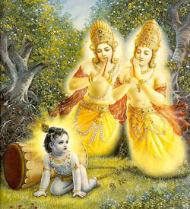
Through His Damodara lila, Lord Krishna liberated the two sons of Kuvera from the curse of Narada Muni and made them His pure devotees.

- Damodarashtakam
This song describes the wonderful pastime of Lord Krishna where His mother tries to punish Him for stealing butter from the gopis. For this special month of Karttika, devotees around the world sing these prayers every day. Each verse describes wonderful qualities or features of the Lord. This year, Karttika starts on October 22nd and ends on November 21st.
(1)
namāmīśvaram sac-cid-ānanda-rūpam
lasat-kuṇḍalam gokule bhrājamanam
yaśodā-bhiyolūkhalād dhāvamānam
parāmṛṣṭam atyantato drutya gopyā

(2)
rudantam muhur netra-yugmam mṛjantam
karāmbhoja-yugmena sātańka-netram
muhuḥ śvāsa-kampa-trirekhāńka-kaṇṭha-
sthita-graivam dāmodaram bhakti-baddham

(3)
itīdṛk sva-līlābhir ānanda-kuṇḍe
sva-ghoṣam nimajjantam ākhyāpayantam
tadīyeṣita-jñeṣu bhaktair jitatvam
punaḥ prematas tam śatāvṛtti vande

(4)
varam deva mokṣam na mokṣāvadhim vā
na canyam vṛṇe ‘ham vareṣād apīha
idam te vapur nātha gopāla-bālam
sadā me manasy āvirāstām kim anyaiḥ

(5)
idam te mukhāmbhojam atyanta-nīlair
vṛtam kuntalaiḥ snigdha-raktaiś ca gopyā
muhuś cumbitam bimba-raktādharam me
manasy āvirāstām alam lakṣa-lābhaiḥ

(6)
namo deva dāmodarānanta viṣṇo
prasīda prabho duḥkha-jālābdhi-magnam
kṛpā-dṛṣṭi-vṛṣṭyāti-dīnam batānu
gṛhāṇeṣa mām ajñam edhy akṣi-dṛśyaḥ

(7)
kuverātmajau baddha-mūrtyaiva yadvat
tvayā mocitau bhakti-bhājau kṛtau ca
tathā prema-bhaktim svakām me prayaccha
na mokṣe graho me ‘sti dāmodareha

(8)
namas te 'stu dāmne sphurad-dīpti-dhāmne
tvadīyodarāyātha viśvasya dhāmne
namo rādhikāyai tvadīya-priyāyai
namo 'nanta-līlāya devāya tubhyam
TRANSLATION
1) To the supreme controller, who possesses and eternal form of blissful knowledge, whose glistening earrings swing to and fro, who manifest Himself in Gokula, who stole the butter that the gopis kept hanging from the rafters of their storerooms and who then quickly jumped up and ran in retreat in fear of Mother Yasoda but was ultimately caught - to that Supreme Lord, Sri Damodara, I offer my humble obeisances.
2) Upon seeing His mother's whipping stick, He cried and rubbed His eyes again and again with His two lotus hands. His eyes were fearful and His breathing quick, and as Mother Yasoda bound His belly with ropes, He shivered in fright and His pearl necklace shook. To this Supreme Lord, Sri Damodara, I offer my humble obeisances.
3) Those superexcellent pastimes of Lord Krsna's babyhood drowned the inhabitants of Gokula in pools of ecstasy. To the devotees who are attracted only to His majestic aspect of Narayana in Vaikuntha, the Lord herein reveals: “I am conquered and overwhelmed by pure loving devotion.” To the Supreme Lord, Damodara, my obeisances hundreds and hundreds of times.
4) O Lord, although You are able to give all kinds of benedictions, I do not pray to You for liberation, nor eternal life in Vaikuntha, nor any other boon. My only prayer is that Your childhood pastimes may constantly appear in my mind. O Lord, I do not even want to know your feature of Paramatma. I simply wish that Your childhood pastimes may ever be enacted in my heart.
5) O Lord, the cheeks of Your blackish lotus face, which is encircled by locks of curling hair, have become reddened like bimba fruits due to Mother Yasoda's kisses. What more can I describe than this? Millions of opulences are of no use to me, but may this vision constantly remain in my mind.
6) O unlimited Visnu! O master! O Lord! Be pleased upon me! I am drowning in an ocean of sorrow and am almost like a dead man. Please shower the rain of mercy on me; uplift me and protect me with Your nectarean vision.
7) O Lord Damodara, in Your form as a baby Mother Yasoda bound You to a grinding stone with a rope for tying cows. You then freed the sons of Kuvera, Manigriva and Nalakuvara, who were cursed to stand as trees and You gave them the chance to become Your devotees. Please bless me in this same way. I have no desire for liberation into Your effulgence.
8) O Lord, the entire universe was created by Lord Brahma, who was born from Your abdomen, which was bound by a rope by Mother Yasoda. To this rope I offer my humble obeisances. I offer my obeisances to Your most beloved Srimati Radharani and to Your unlimited pastimes.

Hare Krishna!

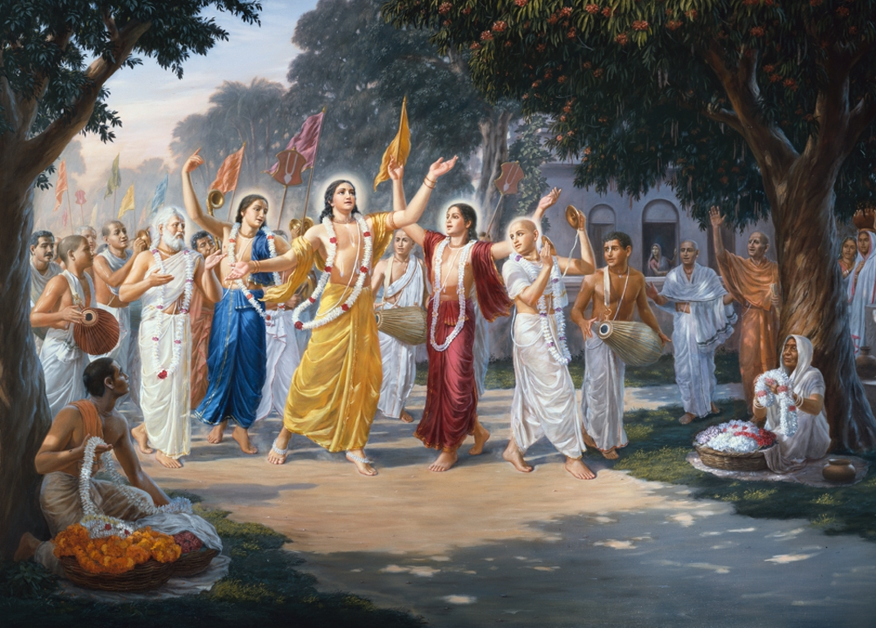
Harinama Sankirtana is the Yuga Dharma for the age of Kali or Kali Yuga. Lord Sri Krishna Chaitanya Mahaprabhu popularized this form of worship in 15th century India.
- Yuga Dharma
Yuga means an age or millennium. According to the sacred scriptures there are four such Yugas in one day of Brahma which is known as a Kalpa. Satya Yuga, Treta Yuga, Dwapara Yuga and Kali Yuga are the four yugas as per the shastras. These Yugas are similar to the different ages mentioned in Greek philosophy such as the golden age, silver age, bronze age and iron age. As time passes on and millenniums change, sins, evil, impious activities, immorality, irreligion and atheism increase in human society with every passing age.
Sins are at the minimum or next to nil in satya yuga. This golden age lasts for nearly 17,28ooo years. In Treta yuga, immorality and impiousness is injected in human society and begins to rise. This Yuga lasts for nearly 12,96,000 years. The Dwapara Yuga is characterized with a further increase in immorality and impious activities. This age lasts for nearly 8,64,000 years. In the Kali Yuga which lasts for 4,32,000 years, sins at their apex and this age ends with Lord Sri Krishna coming in the form of Lord Kalki for the deliverance of His devotees and for annihilating the sinners and for reestablishment of the Satya Yuga.
The recommended methods of worship are different for different ages. The prescribed method of worship of the supreme lord in a particular age is known as the Yuga Dharma of that particular age. In the Satya Yuga, the Yuga Dharma was meditation. People in that age had an average life span of 100,000 years! Thus, it was possible for them to do austerities and meditate for thousands of years and achieve perfection. In the Treta Yuga, the Yuga Dharma was the performance of various sacrifices, penances and pilgrimages. The Yuga Dharma of Dwapara Yuga was temple and deity worship. In the Kali Yuga however, these methods maybe useful in bringing one to the platform of spirituality and spiritual inquiry but the Yuga Dharma for this age is Harinama Sankirtan or chanting the names and glories of Lord Sri Krishna. This method of worship was popularized by Lord Sri Krishna Chaitanya Mahaprabhu who was the incarnation of Lord Krishna Himself in the 15th century in India.
In the Srimad Bhagavatam 11.5.36, it is stated: kaler dosa-nidhe rajann asti hy eko mahan gunah kirtanad eva krsnasya mukta-sangah param vrajet krte yad dhyayato visnum tretayam yajato makhaih dvapare paricaryayam kalau tad dhari-kirtanat "The most important factor in this Age of Kali, which is an ocean of faults, is that one can be free from all contamination and become eligible to enter the kingdom of God simply by chanting the holy names. The self-realization that was achieved in the Satya millennium by meditation, in the Treta millennium by the performance of different sacrifices, and in the Dvapara millennium by worship of Lord Krsna can be achieved in the Age of Kali simply by chanting the holy names." (12.3.51-2)
krsna varnam tvisakrsnam sangopangastra parsadam yajnaih sankirtana prayair yajanti hi sumedhasah
“In the age of Kali, intelligent persons perform congregational chanting to worship the incarnation of Godhead who constantly sings the holy name of Krsna. Although His complexion is not blackish, He is Krsna Himself. He is accompanied by His associates, servants, weapons and confidential companions.” (Srimad Bhagavatam (11.5.32))
hari-nama-para ye ca hari-kirtana tat parah hari-puja-para ye ca te krtarthah kalau-yuge
"Those who engage in chanting the holy name of Lord Hari (japa), are addicted to congregational chanting (kirtana) and engage in the worship of Lord Hari, have accomplished their desires in the age of Kali." (Brhan-naradiya Purana)
dhyayan krte yajan yajnais tretayam dvapare ’rcayan yad apnoti tad apnoti kalau sankirtya kesavam "Whatever is achieved in Satya-yuga by meditation, in Treta by offering ritual sacrifices and in Dvapara by temple worship is achieved in Kali-yuga by chanting the names of Lord Kesava congregationally." (Padma Purana, Uttara Khanda 42nd Chapter)
namno hi yavati saktih papa-nirarane hareh tavat kartum na saknoti patakam pataki narah
Simply by chanting the holy name of Hari, a sinful man can counteract the reactions of more sins than he is able to commit.
Furthermore, Sri Ananta-samhita states:
hare krsna hare krsna krsna krsna hare hare | hare rama hare rama rama rama hare hare || sodasaitani namani dvatrimsad varnakani hi | kalau yuge maha-mantrah sammato jivatarane || varjayitva tu namaitad durjanaih parikalpitam | chandobaddham susiddhanta viruddham nabhyaset padam || tarakam brahma-namaitad brahmana gurunadina | kalisantaranadyasu sruti-svadhigatam hareh || praptam sri brahma-sisyena sri naradena dhimata | namaitad-uttamam srauta-paramparyena brahmanah || utsrjyaitan-maha-mantram ye tvanyat kalpitam padam | mahanameti gayanti te sastra-guru langhanah || tattva-virodha-sanprktam tadrsam daurjanam matam | sravatha pariharyam syadatma-hitarthina sada || hare krsna hare krsna krsna krsna hare hare | hare rama hare rama rama rama hare hare ||
“’Hare Krsna Hare Krsna Krsna Krsna Hare Hare Hare Rama Hare Rama Rama Rama Hare Hare’ - This sixteen-name, thirty-two syllable mantra is the maha-mantra in Kali-yuga by which all living beings can be delivered. One should never abandon chanting this maha-mantra and take to other so-called purificatory processes which are practiced by rascals, or engage in chanting other metrical compositions of the name of Krishna that are against the pure conclusions of the scriptures, or are filled with rasaabhaas. About this divinely spiritual maha-mantra, which delivers one from material existence, the original guru, Lord Brahma, has said, kali-santararadi sruti, "The srutis have declared this mantra to be the best means of deliverance in the age of Kali". Having all heard this from Brahma, the sons and disciples of Brahma, beginning with Narada, all accepted the Hare Krishna maha-mantra and, having meditated on it, attained perfection.
Hence, abiding by the Yuga Dharma for the present age of Kali which is characterized by quarrel and hypocrisy, we must follow in the footsteps of Lord Chaitanya Mahaprabhu and incessantly chant the names and glories of Lord Sri Krishna. The Hare Krishna Mahamantra is the recommended and authorized mantra for this age and there are no hard rules and regulations for chanting it. Anyone can chant it anywhere and at any time and receive the mercy of Lord Krishna in the form of liberation from maya.
Hare Krishna!
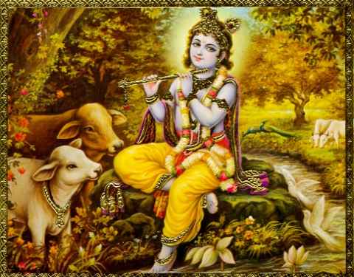
- The Significance of Vegetarianism
The food that we eat goes to make up our tissues and brain cells. It influences our thoughts and actions. Hence, it is rightly said that “you are what you eat.” If a person consumes meat, flesh, eggs and other abominable stuff, it would lead to abominable thoughts and actions on the part of that person. It is also scientifically proven that the people who consume meat are more prone to heart, blood and stomach related diseases. High blood pressure, heart attack, stroke etc are also common among meat eaters. On the other hand, those who are vegetarians are known to live longer and healthier lives. Vegetarians are less prone to obesity and heart related ailments. Hence, at least for the sake of one’s health one should stop consuming meat of all kinds.
The appropriate eatables for man are food grains, vegetables, fruits and milk products. The non-vegetarians often argue that vegetarian food is not very energetic and scarce in essential nutrients and fats. But this is a wrong notion created by the companies selling non-vegetarian products. Milk products like curd are excellent sources of protein, milk is rich in fats and so are potatoes. One need not kill animals for fat since it is available in vegetarian food stuffs. Fruits are good sources of essential vitamins. In this way, vegetarian food is amply rich in all essential proteins, vitamins, minerals and fats.
Even if one is consuming pure vegetarian food, it must be first offered to Lord Krishna as bhog and should be eaten later as prasadam or sanctified food. Otherwise, whatever one eats is karmic food and is the cause of sinful reactions. But what kind of food can be offered to Lord Krishna and how? In the 9th chapter of Bhagavad Gita, verse 26, the Lord says “One who offers me with love and devotion a leaf, a flower, a fruit or a little water, I will accept it.”
The above verse confirms what the Lord actually wants us to offer Him. He does not ask for abominable things like meat or flesh but pure things like a leaf, a flower, a fruit or a little water. One must note that the leaf mentioned in the above verse refers to the Tulsi leaf which is very dear to the Lord and He does not accept any offerings without her. Hence, one must offer only pure vegetarian things to the Lord along with a tulsi leaf. This offering should be made with pure love and devotion. Only then it shall be accepted by the lord as He confirms in the above verse. In this manner, one must offer pure vegetarian food to the Lord as bhog and later distribute the prasadam among family and friends and also eat it himself. This purifies one’s mind and body and eradicates all sins. Prasadam is very potent in bringing even the most degraded men to the platform of pure devotional service. One must keep in mind that even certain vegetarian eatables like onion, garlic and masoor dal are prohibited since they are not considered pure vegetarian in a strict sense.
The one who abides by this method and eats nothing which is not offered to or is not worthy of being offered to Lord Krishna, is elevated to the platform of pure devotional service and gains the physical and mental purity for understanding the sacred scriptures and discharging devotional service. On the other hand, those who eat meat are committing gross sins. Killing innocent creatures for one’s own sense gratification is a serious offence especially when appropriate alternatives in the form of pure vegetarian food are available. Nature’s laws of karma that is action and reaction ensure that violence is paid back in violence. Where there are people who kill innocent creatures to fill their own stomachs and that of their loved ones, nature ensures that such people suffer in a similar manner as those innocent creatures that were killed by or for these meat eaters. Among the meat eaters too, the worst category is of the one’s who consume cow and buffalo meat. According to the sacred scripture, cow is a mother to human society since she selflessly nourishes us with her wholesome milk and the bulls are considered as fathers of human society since they toil in the farms for providing us with agricultural products. Cow is also the dearest of all creatures to Lord Krishna. Hence, killing of cows is the greatest of all sins. It is very unfortunate that even in a country like India where cows are revered as sacred by the majority of the population which is Hindu; still there are slaughter houses where more than 50,000 cows are slaughtered daily. Cow slaughter is the greatest sin and there is no mercy for a cow slaughterer in the three worlds. They are sent to the most abominable hells where they suffer for their sinful actions. Hence, even if one be a non-vegetarian he must avoid eating cow flesh. We all consume cow milk in some or the other form like milk, cheese, butter, ghee, curd, ice creams etc. So it is not very prudent to say that we are not in debt to cows at all. One must eat pure vegetarian food to avoid unnecessary sins of killing and eating innocent creatures. Pure vegetarian food helps one elevate his consciousness and understand the injunctions of the sacred scriptures. This helps one in the discharge of his prescribed duties and devotional service. Carrying out one’s prescribed duties and discharging devotional service to Lord Krishna, one becomes and fit candidate to go back home, back to godhead. Hare Krishna!
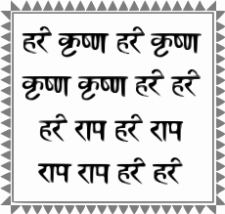

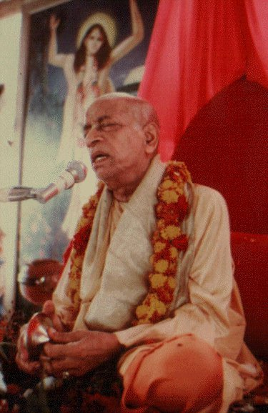
Dedicated to His Divine Grace A.C. Bhaktivedanta Swami Prabhupada, Founder Acharya of the International Society for Krishna Consciousness, ISKCON.
Written, edited, published and distributed by,
Rasabihari Dasa (Vinay D Chakraborty)

Do send in your views, suggestions and queries to vinay.chakraborty@yahoo.com or visit- www.soldiersofgodhead.yolasite.com for more information.

Is there a subject on which you want an article in the Soldiers of Godhead? Or an article that you want to write for this magazine? Mail me your article on my email id mentioned above and I’ll include it in an edition. Hare Krishna!!! Haribol!!!

Hare Krishna!

